**Project Title- Application Load Balancers _ How to create an internet facing load balancer in AWS_**

**Types of Load Balancers**

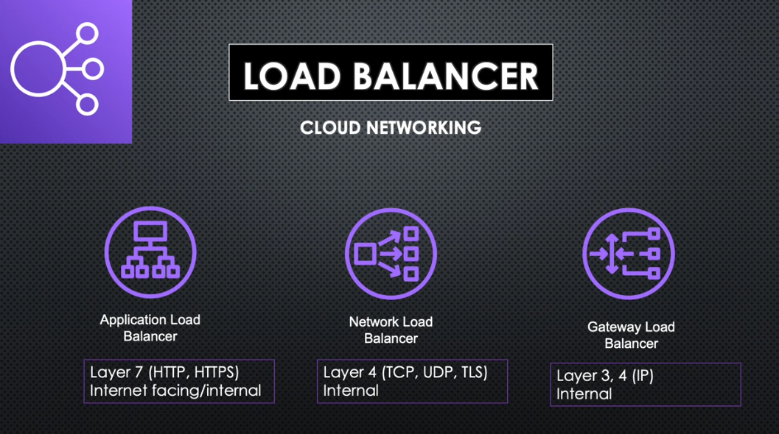

**Application Load Balancer**

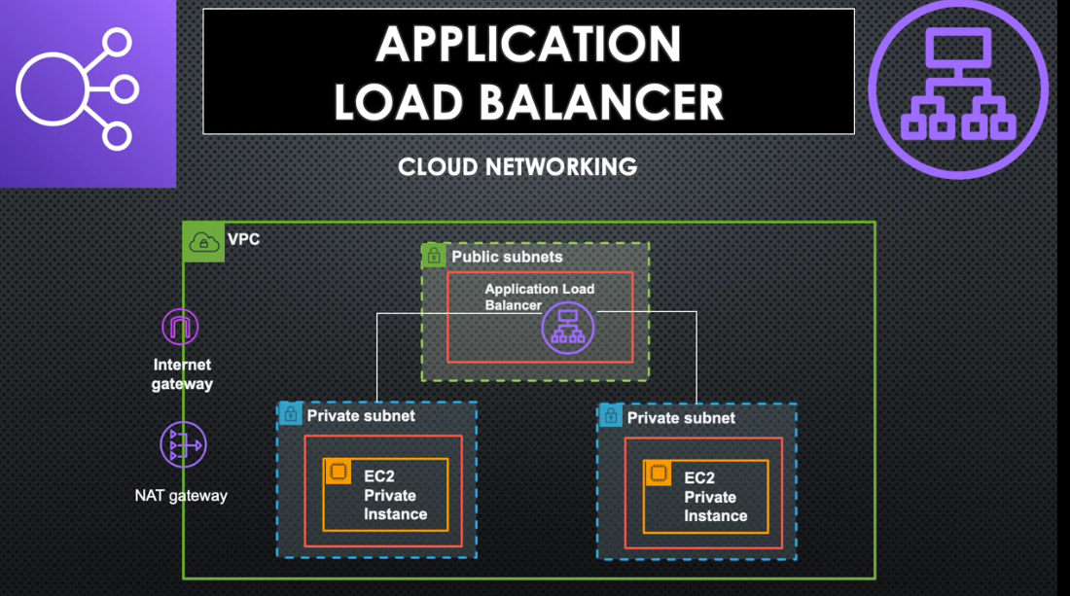

**Log in to your AWS Account and Create the infrastructure starting with VPC creation eg Brixglot-vpc**

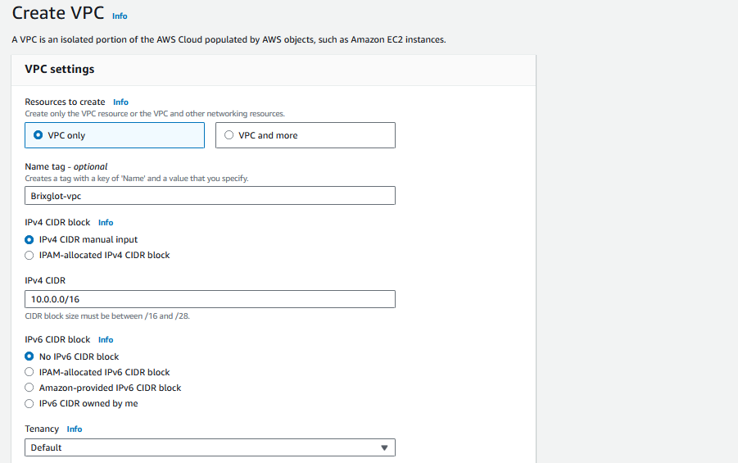

**Create 4 subnets (2 Public and 2 Private) under the VPC with their availability zones>>>under vpc choose Subnets>>>assign each public subnet to each corresponding private subnet eg PubSub1 >>>PrivSub1 and PubSub2>>>PrivSub2**

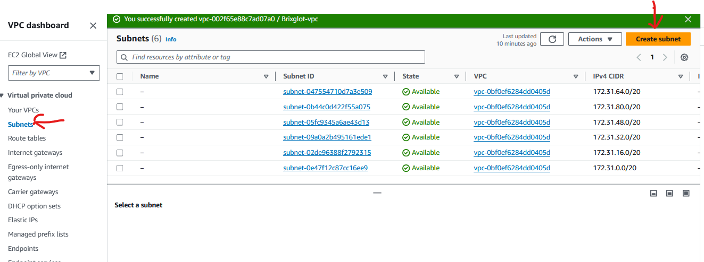

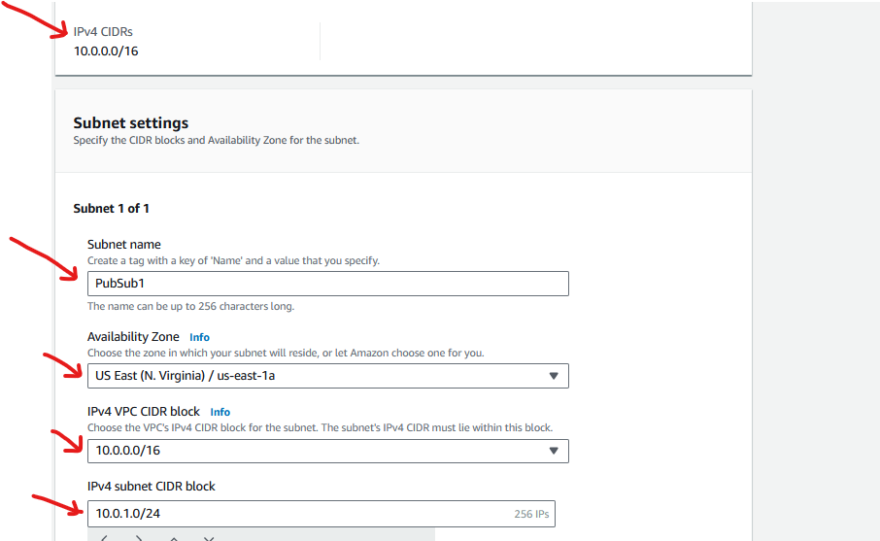

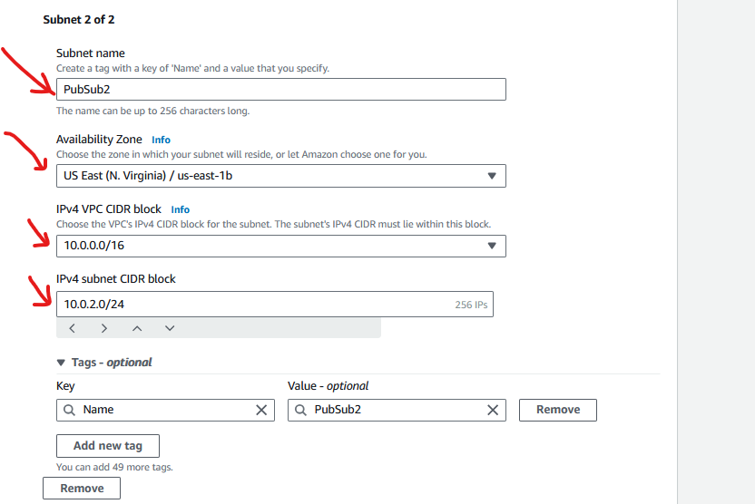

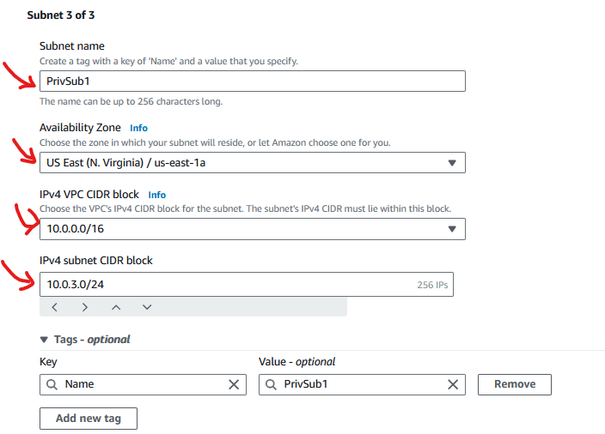

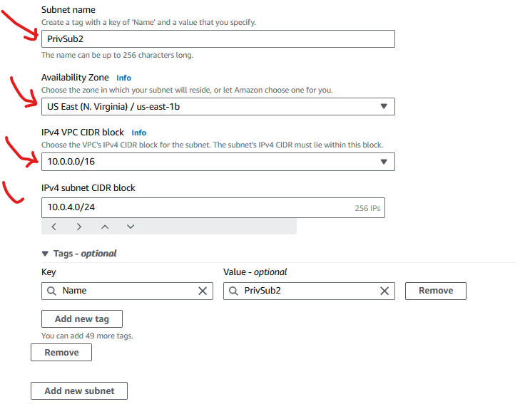

**Create the Internet Gateways and attach to the VPC eg Brixglot-vpc**

**Internet Gateway-under VPC>>>Internet Gateways>>>create Internet Gateway**

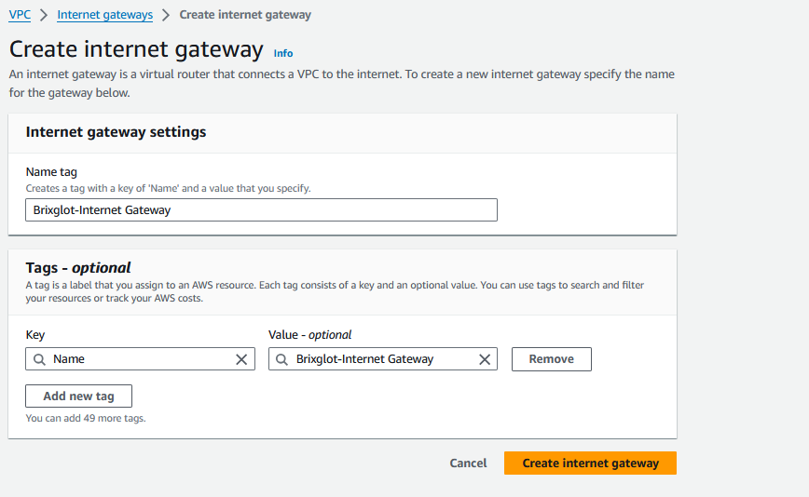

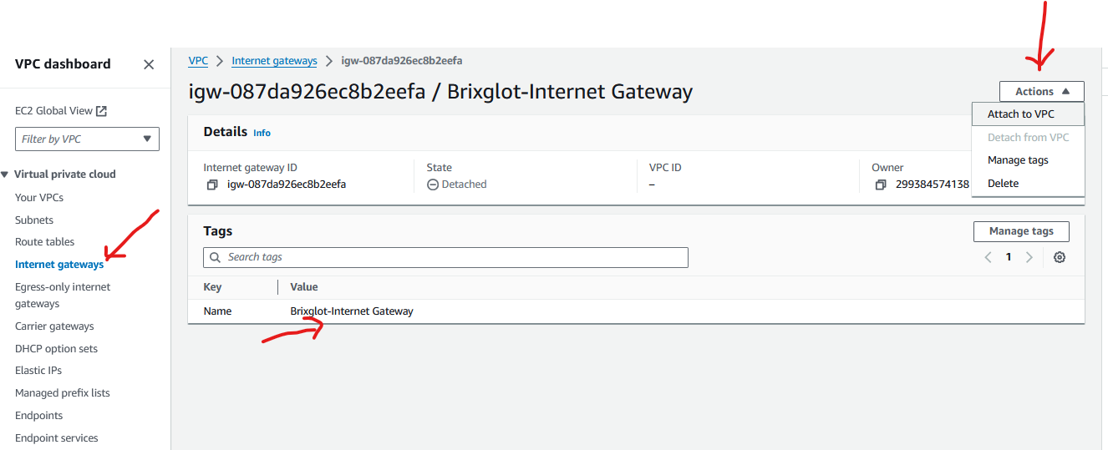

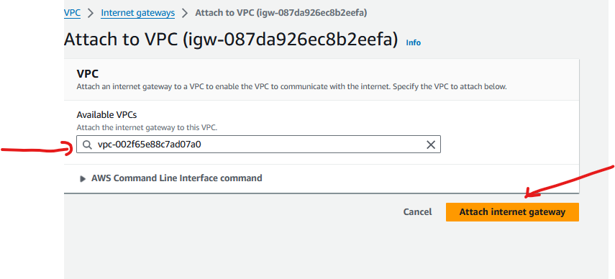

**Create the NAT Gateways (this wll take care of the Private VMs) and host it in the Public Subnet eg PubSub1, click the allocate Elastic IP so your Private VMs will have internet access**

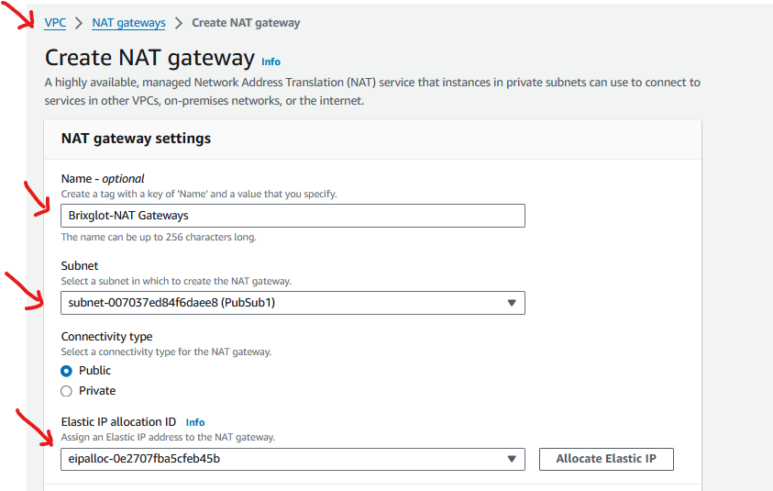

**Go to Route Tables to add the routes for Internet Connectivity**

**Create a Route Table and add to your vpc eg Brixglot-vpc**

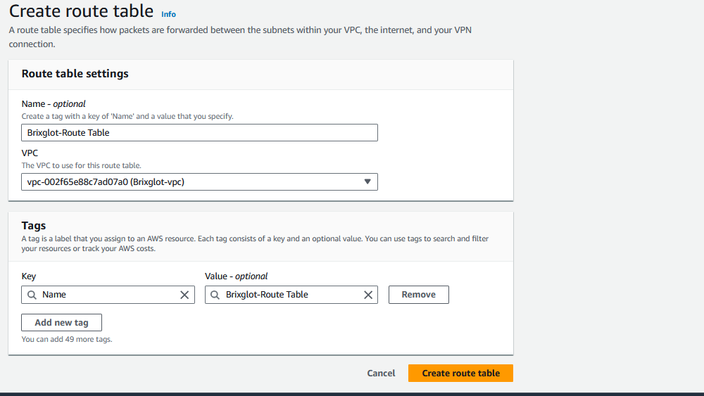

**Edit the created Routes, add 0.0.0.0/0 and associate the 2 Public Subnets (PubSub1 & PubSub2) to this Route Table ie. PubSub1 & PubSub2>>>Brixglot-Route Table**

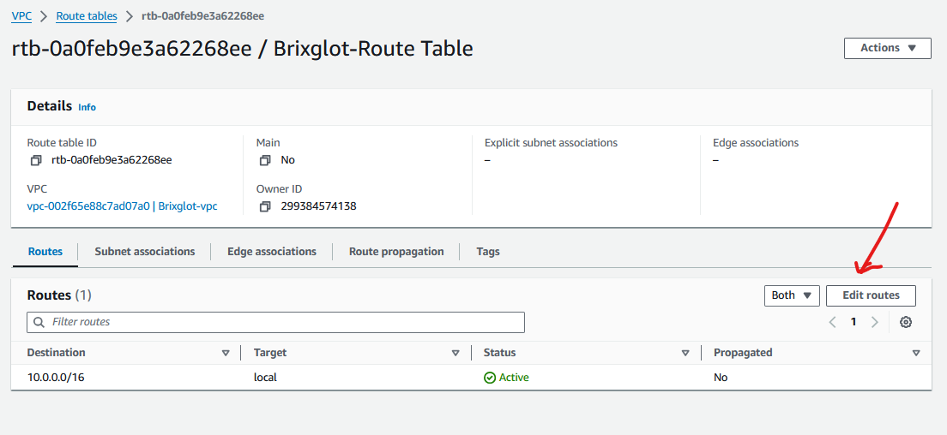

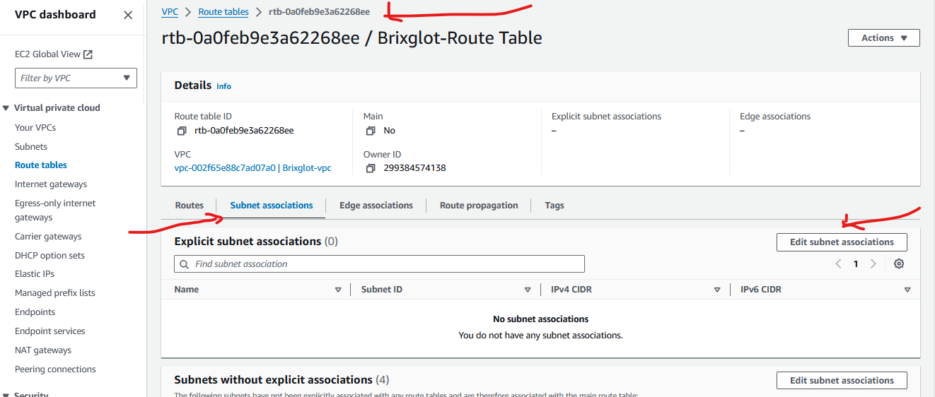

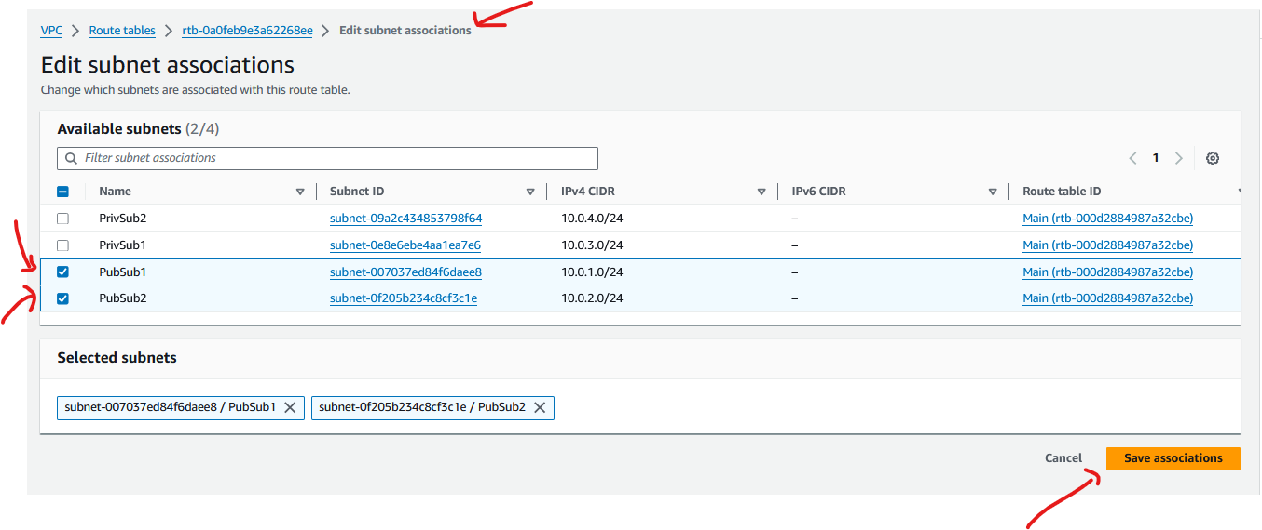

**Create NAT Routes to establish the Routes via Nat Gateways**

**Edit the Nat Routes, add 0.0.0.0/0 to NAT Gateways this time around.**

**Associate the 2 Private Subnets (PrivSub1 & PrivSub2) to the Nat Routes**

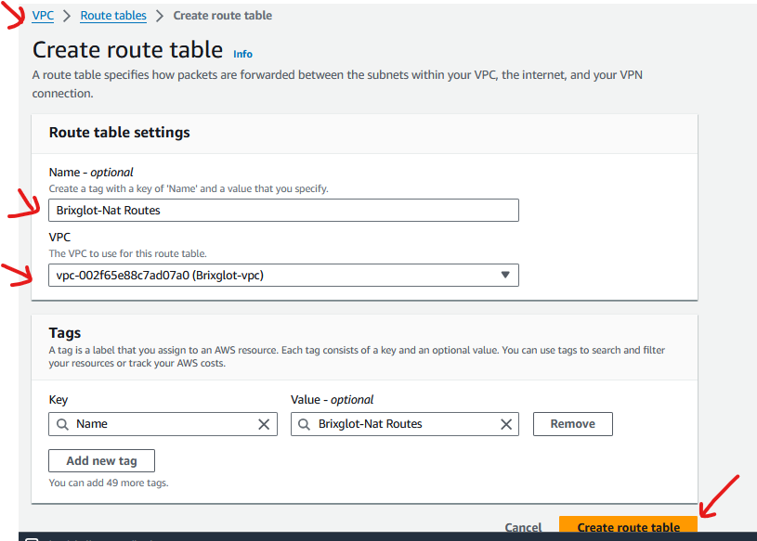

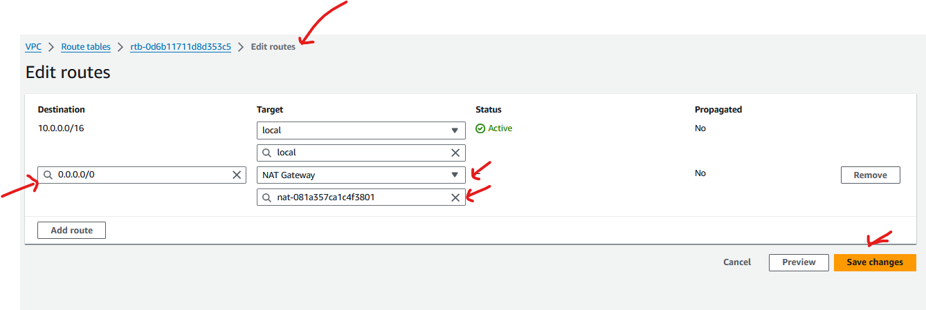

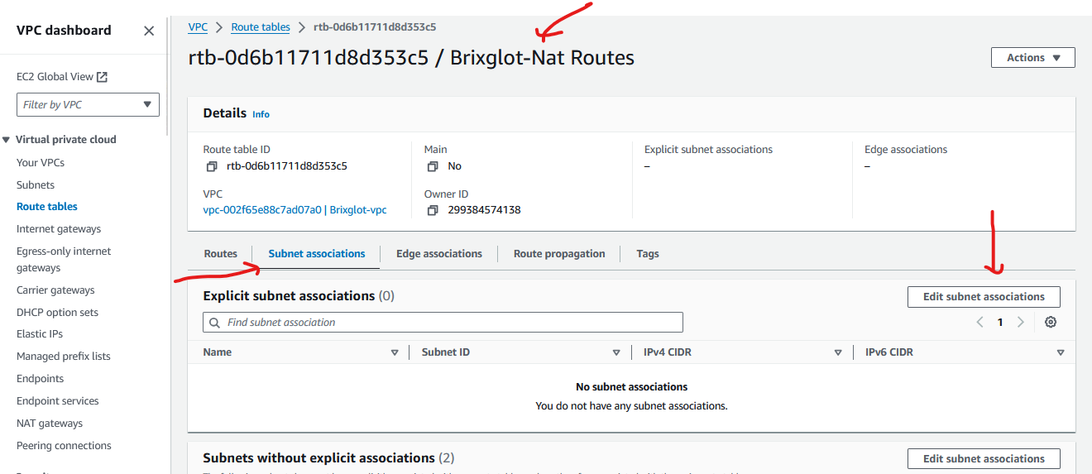

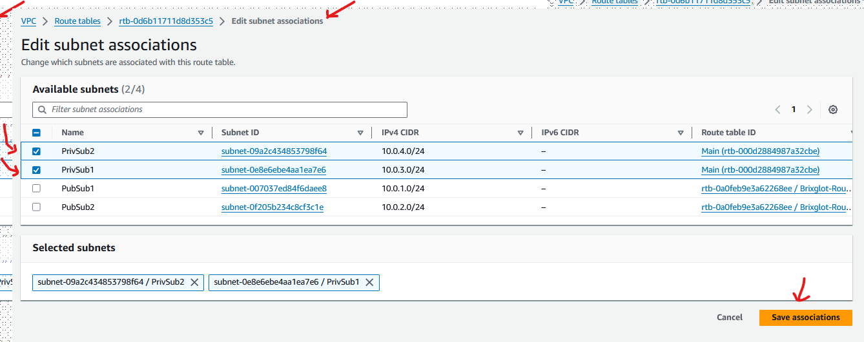

**The base Infrastructure is concluded now.**

**Next steps is to create the VMs(EC2).**

**Create 2 servers under the 2 Private subnets**

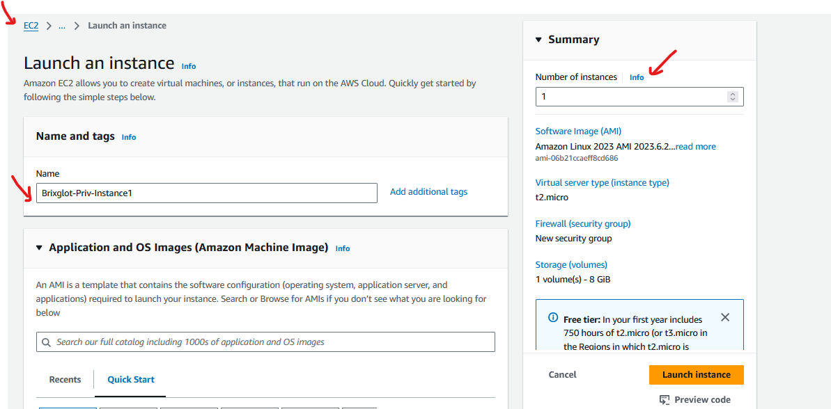

**Choose Free Tier**

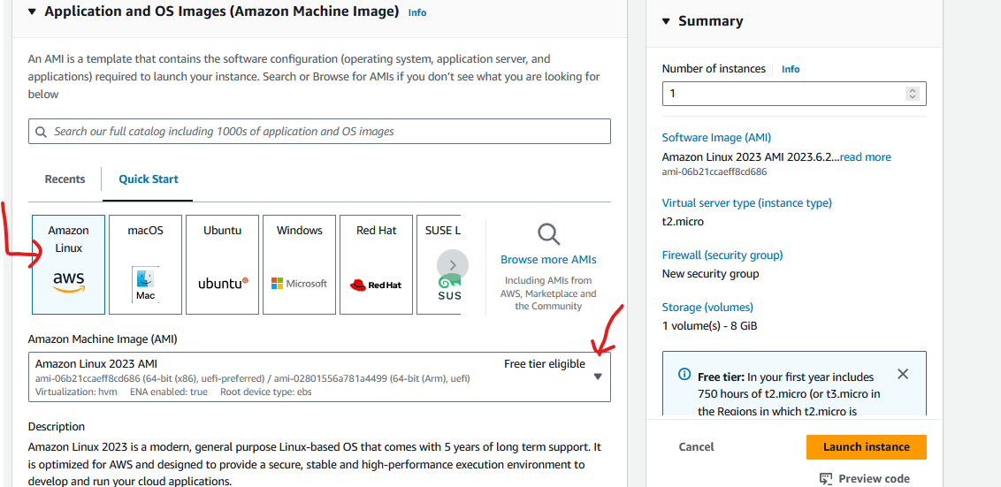

**Create a keypair (leave empty for this lab sample)**

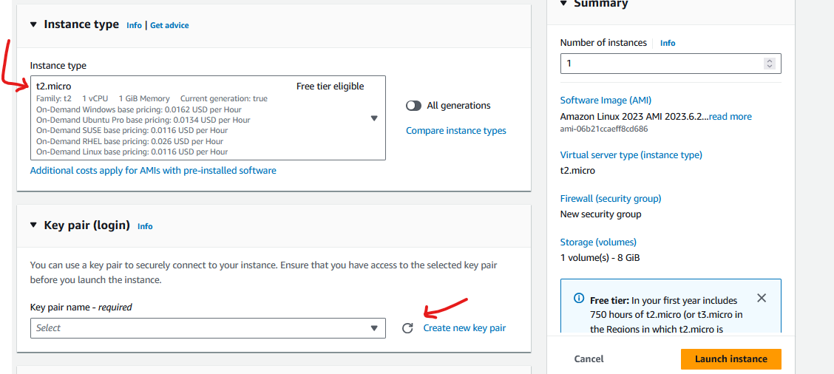

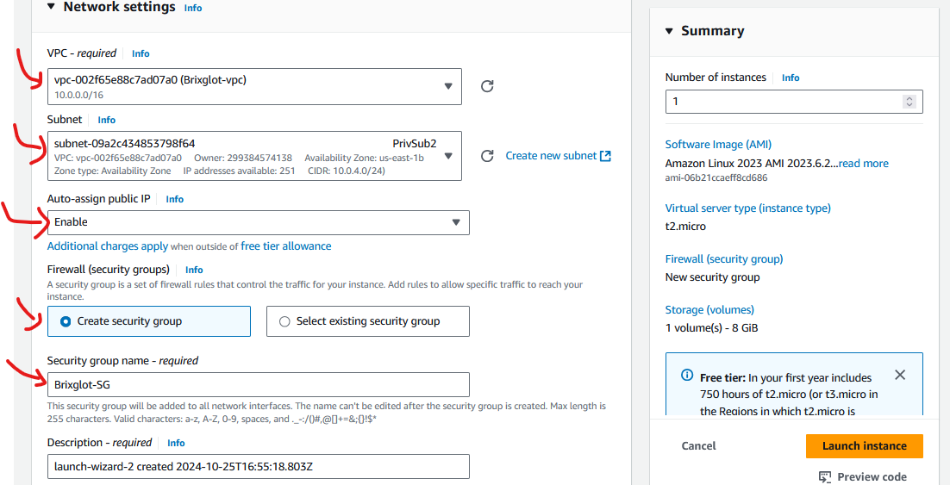

**Enable Security Group to allow SSH to your IP**

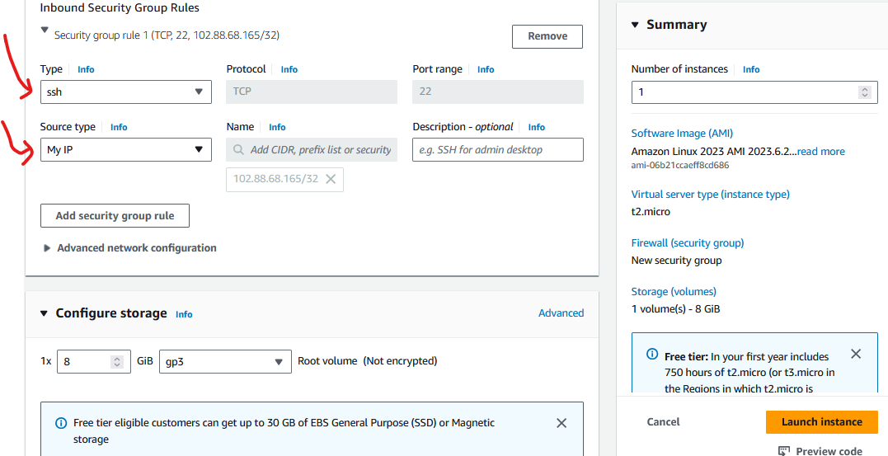

**Sample User Data**

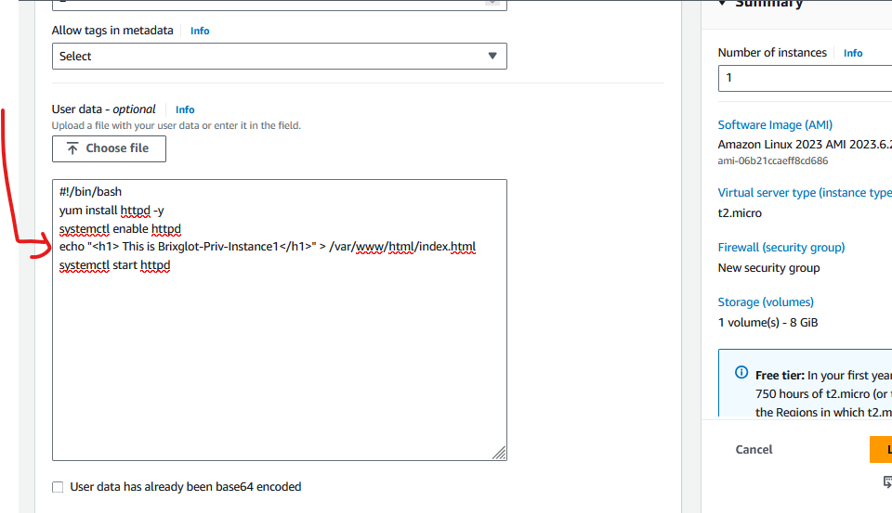

**Follow same example above and launch another instance but put in 2nd Private subnet ie PrivSub1.**

**Paste the same Bas Script but chance to Brixglot-Priv-instance2**

#!/bin/bash

yum install httpd -y

systemctl enable httpd

echo "<h1> This is Brixglot-Priv-Instance2</h1>" > /var/www/html/index.html

systemctl start httpd

Select the existing Security Group i.ie Brixglot-SG we just created

**Create the Load Balancers**

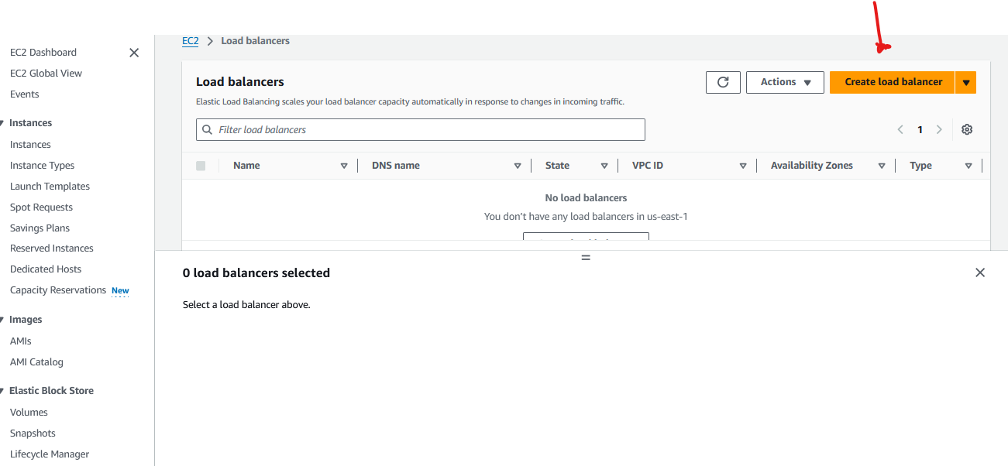

**Choose Application Load Balancer**

**Customer a name for your Load Balancer eg Brixglot-ALB**

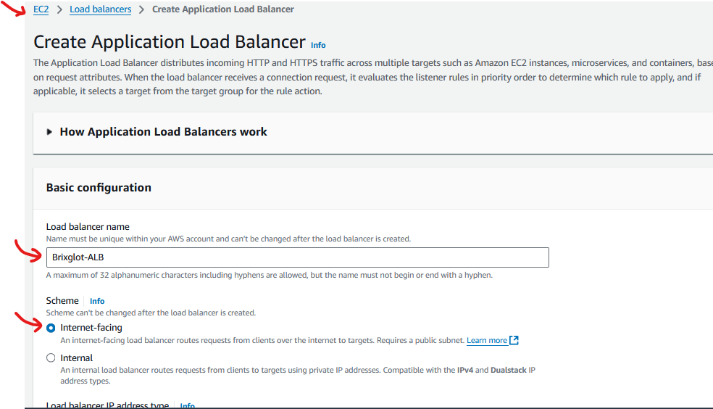

**Select the listeners that the Load Balancer Port listens to, select the public subnets under the vpc where the ALB will be placed**

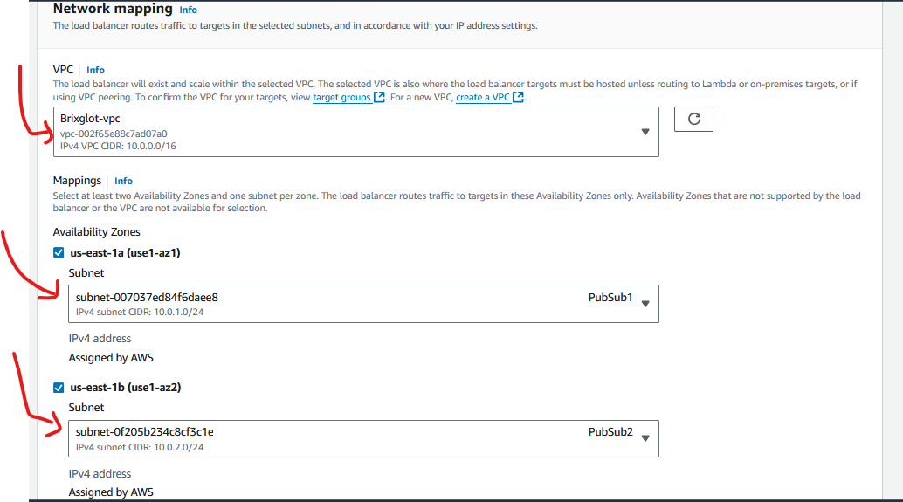

**Create a new Security Group where the Load Balancer will be placed, register(Add) your VMs ie the 2 Private Instances to the Target Group of the Load Balancer**

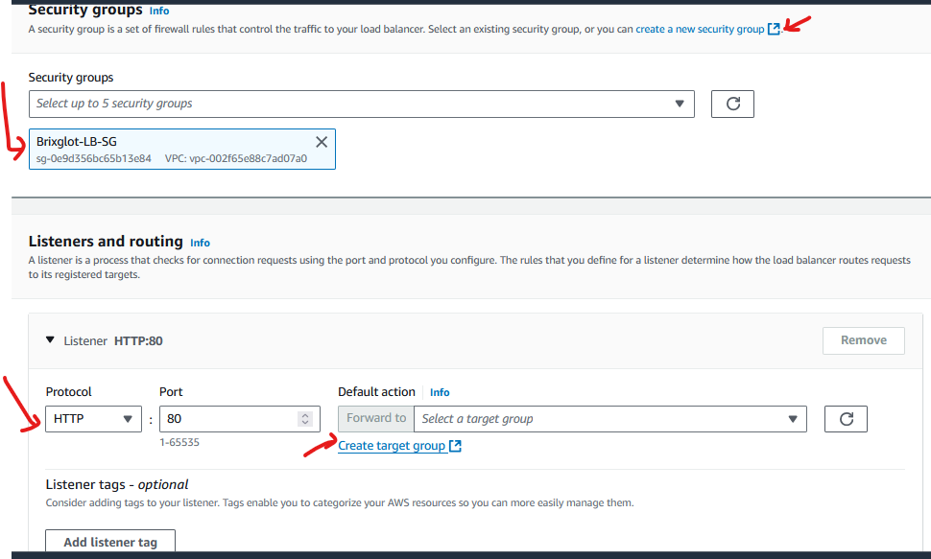

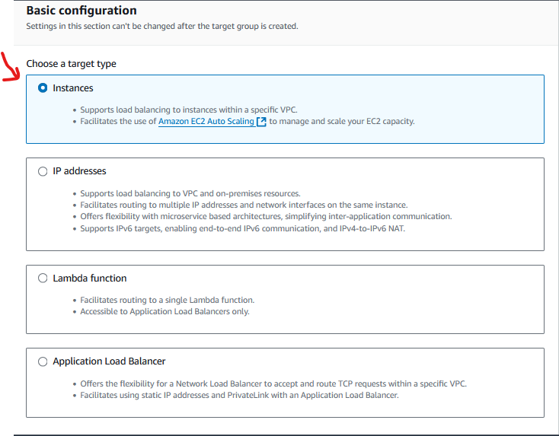

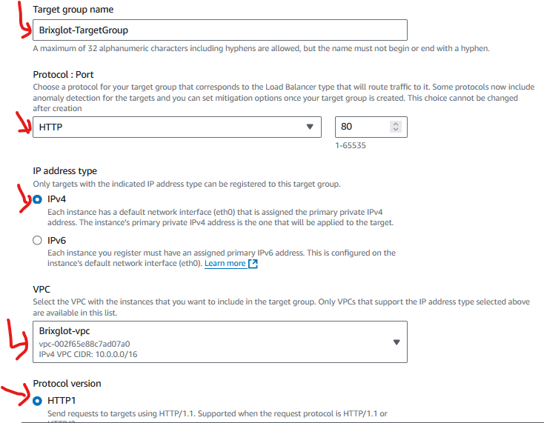

**Confirm that your health checks are set -Health checks is the amount of time your Load balancer waits before determining wither your Instances(VMs) are healthy or not ( you can leave the default values)**

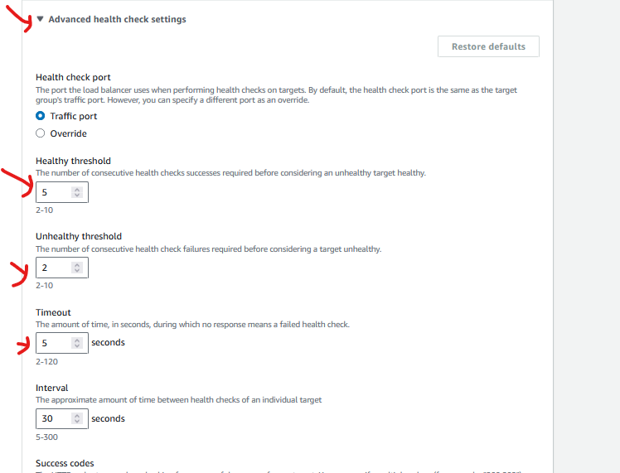

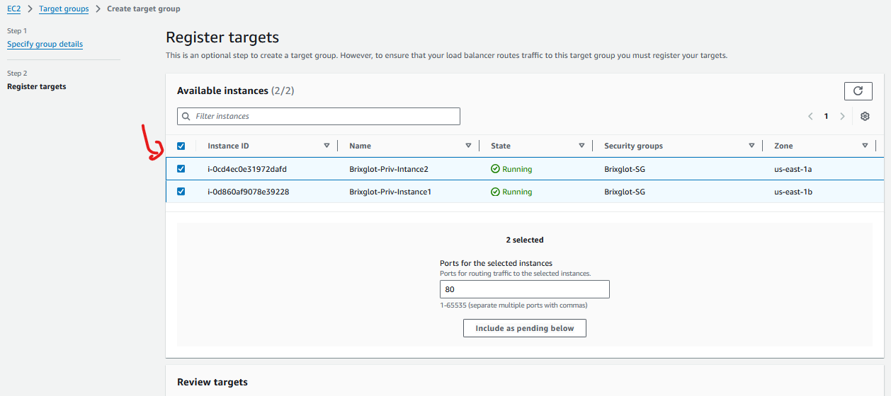

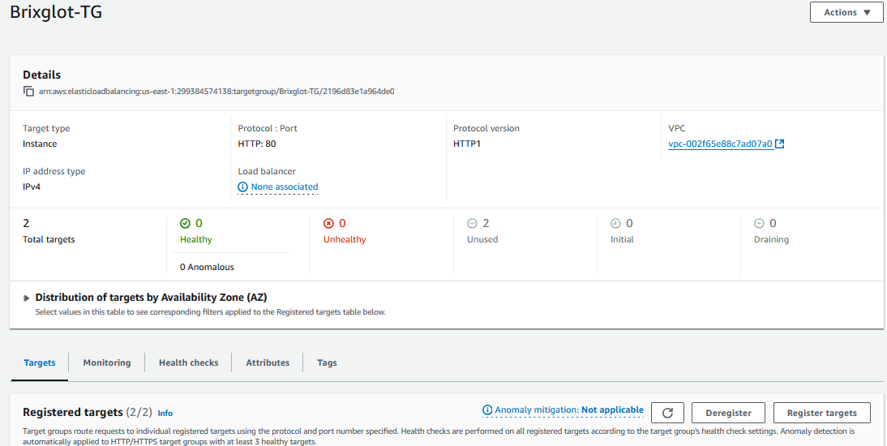

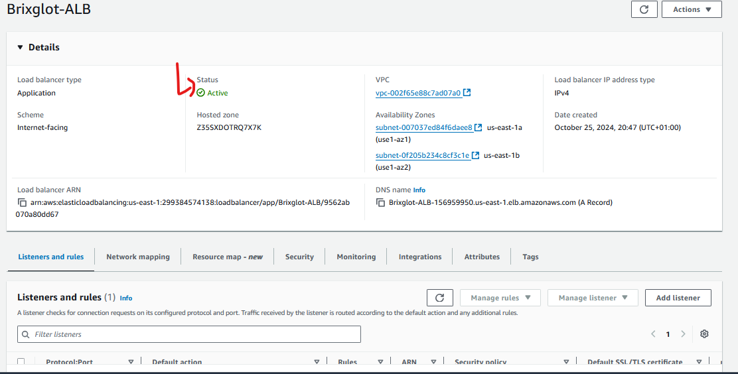

Last thing to do is to Edit the Security Group of the 2 Private Instances to allow traffic to the VMs through the Load Balancers

Edit the Inbound Rules of the VMs Sec. Group to allow traffic from the security group of load balancer ie Brixglot-LB-SG

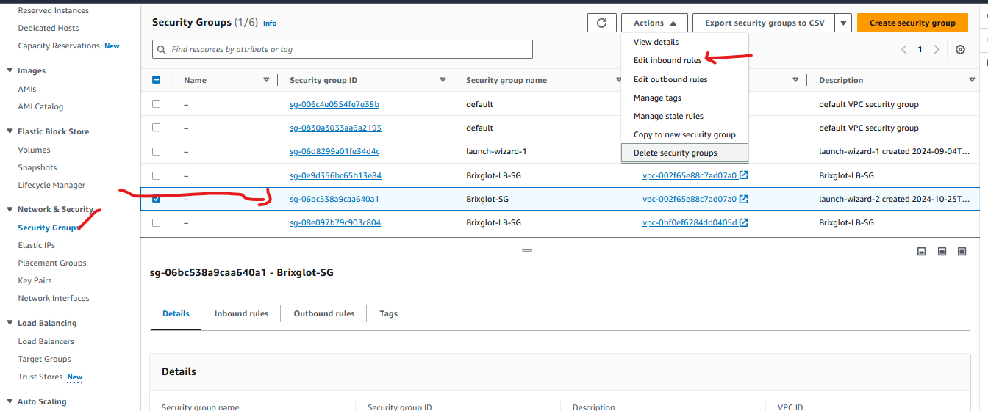

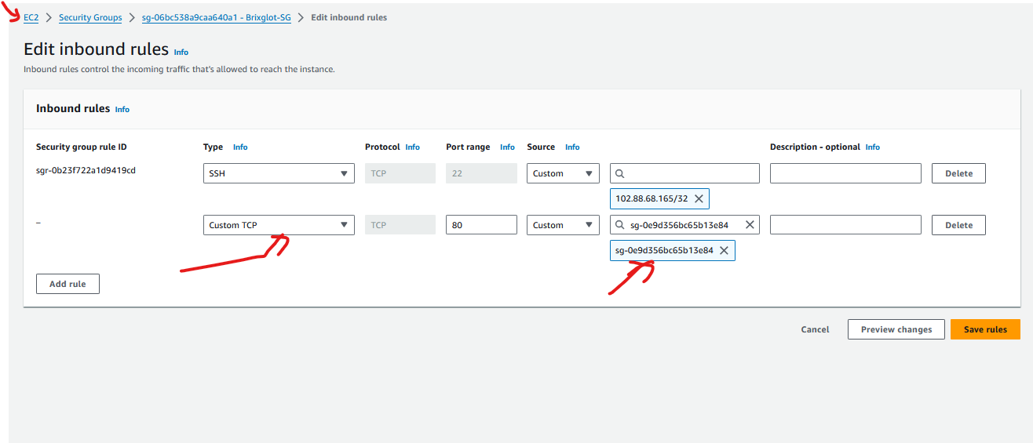

Go back to your Target Groups and check the health status.

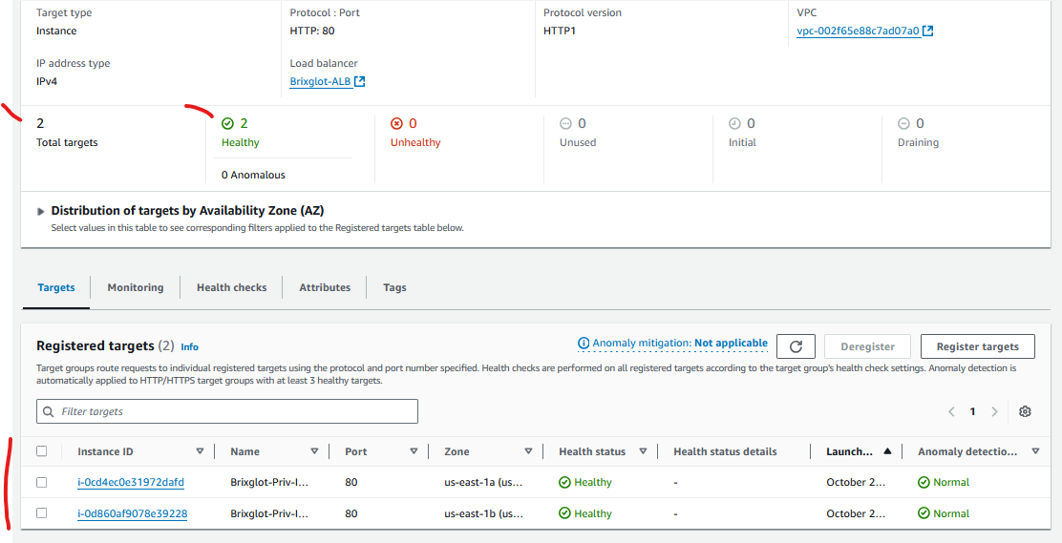

Go to the Load Balancers and copy the DNS name, paste in your browser and confirm you could reach your Instances, refresh the bowser to access the different instances.

